Harshvardhan Tiwari, Shivani S Pai, Sumanth N S, Arundathi S Hegde

A Machine Vision Techniques Based Tongue Diagnosis System in Ayurveda

Harshvardhan Tiwari

Centre for Incubation, Innovation, Research and Consultancy,

Jyothy Institute of Technology, Bengaluru, Karnataka, India

tiwari.harshvardhan@gmail.com

Shivani S Pai

Information Science and Engineering Department,

Jyothy Institute of Technology, Bengaluru, Karnataka, India

[shivani.pai97@gmail.com](mailto:shivani.pai97@gmail.com)

Sumanth N S

Information Science and Engineering Department,

Jyothy Institute of Technology, Bengaluru, Karnataka, India

[sumanthns211@gmail.com](mailto:sumanthns211@gmail.com)

Arundhati S Hegde

Information Science and Engineering Department,

Jyothy Institute of Technology, Bengaluru, Karnataka, India

arundhatihegde9866@gmail.com

Abstract. : The analysis of the tongue is crucial in the evaluation of the human body in Ayurveda medicine. There is a substantial research scope for tongue diagnosis Ayurvedic therapy. The aim of ourproposed work is to classify the tongue pictures into vata, pitta, kapha (tri-dosha) with the colour, coating, texture and shape features. These characteristics largely also would be determined by the portion of the tongue part (upper region, middle region and sides). Segmentation would be the first section which is of extreme importance which defines the interested region in the tongue image. These features include various colour models and differentiated parts of tongue body. Coating and background also considered for feature set to feed them to the training-testing model for classification. The final outcome of the research is to blend in with the traditional Ayurvedic methods to the machine learning model in a way it describes the most basic class of inspection in medication

1. Introduction

In India and other South Asian countries along with Allopathy, Homeopathy and Naturopathy,Ayurveda medical system is also one of the most popular medical systems . There are four sacred texts called the Vedas namely, Rig Veda (3000-2500 BCE), Yajur Veda, Sam Veda and Atharva Veda (1200-1000 BCE). The word 'Ayurveda' is a Sanskrit word, which means knowledge of life and longevity. Literally, the word Ayurveda is a combination of two words: **Ayuh** +**Veda**,meaning life andscience. It gives a deep insight of the health with universal principles in reference to the connection between mind body and the soul.

According to Thakar(1982) Ayurveda therapies have assorted and developed gradually over greater than two million years. Healing procedures are normally primarily based on complicated natural compounds, minerals and metallic materials. It has gathered an understanding of disease diagnosis and remedy formulated by using several rishis(knowledgeable persons) through thousands of years. As withdifferent medicationsystems, it has its very own information of frame capabilities and the imbalances which motive diseases. Physical observation of body elements of the affected person and modifications in them at some point of the path of remedy is an important manner of diagnosing the disease and fitness condition of the affected person.

The 7 fundamental tissues of ayurveda namely are plasma(rasa tissue), blood(rakta tissue), muscles(mamsa tissue), fat(meda tissue), bone(asthi tissue), marrow(majja tissue) and semen(shukra tissue). Dey, Pahwa (2014) illustrate that these tissues maintain a fundamental character of every individual namely **prakruti**. It is referred as the fundamental characteristic of physical and mental mixture that determine the manner of every being. An individual's prakruthi does not change with the course of his/ her existence. One's prakruti can be influenced by many internal, external and environmental factors.

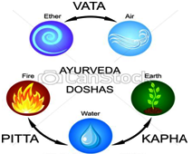

Fig. 1: Five Elements of Body

The ayurveda divides the substances into 5 factors of earth, air, water, fire and space. These factors form the 3 energies known as doshas namely vata( wind element), pitta( fire element) and kapha (earth and water element). These 3 doshas are critical to maintain the health and any imbalance of the 3 would cause health complications.Ayurveda nidan (analysis) methods study approximately bodily, physiological, psychic, and behavioural thing of the patient. Each dosha has each tremendous and negative qualities and is stricken by food, surroundings, lifestyle and movement practices.

* 1. Diagnosis Methods in Ayurveda

In the West, the term diagnosis(analysis) generally refers to identity of the sickness after it has manifested. However, in Ayurveda, the idea of diagnosis refers to moment-to-moment monitoring of the interactions among order (fitness) and ailment(disorder) in the frame.Ayurveda has 8 methods to diagnose illness,referred to as pulse analysis, urine analysis,mala pariksha, tongue diagnosis, speech analysis, touch, vision and appearance.

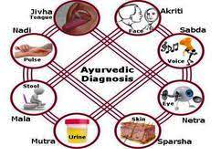

Fig. **2**: Diagnosis Methods in Ayurveda

* + 1. Pulse Diagnosis(Nadi)

One of the essential diagnostic strategies of the historic technological science of Ayurveda is 'Nadivijñan' or Pulse diagnosis. Nadi or pulse is that important go with the flow of strength or lifestyles that guides via a subtle channel everywhere in the body and enables the vaidya to experience the way the blood spurts from the coronary heart. The placement of the index finger indicates the Vatadosha. The middle finger indicates the pulse which corresponds to the Pitta dosha. Whilst the throbbing of the heartbeat beneath the ring finger is max noticeable, it is a sign of Kapha constitution.

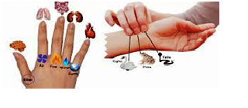

Fig. **3**: Pulse Diagnosis

* + 1. Lip Diagnosis(Ostha)

As with the other features of the body (e.g., tongue, nails, face, eyes), the lips too mirror the health or disorder of the various bodily organs. One should take a look at the scale,form,surface,coloration and contour of the lips. If they are dry and rough this suggests dehydration or a vata derangement.

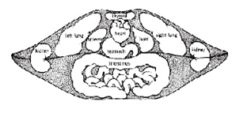

Fig. 4: Lip Diagnosis

* + 1. Nail Diagnosis

In step with Ayurveda, the nails are useless product of the bones. Observe the dimensions, form, surface and contour of your nails. If the nails are free from moisture,curved ,uneven and damage easily, vata predominates in the body. If the nails are tender,soft,pink effortlessly bent and slightly glistening, pitta predominates. Whilst the nails arethick, strong, tender and really bright with a uniform contour, then kapha predominates.

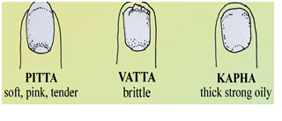

Fig. **5**: Nail Diagnosis

* + 1. Eye Diagnosis

Eyes that are small and blink often show a predominance of vata in the body. Huge, stunning and appealing eyes indicate a kapha constitution. Pitta eyes are satiny and touchy to mild, to, with reddened whites and will be predisposed to be near-sighted. In keeping with Ayurveda, the eyes derive their power from the fundamental fire element.

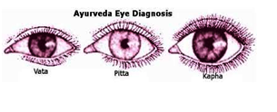

Fig. 6: Eye Diagnosis

1. Tongue Diagnosis in Ayurvedic Treatment

The tongue is one of the vital frame parts that can be analysed to evaluate the exact nature of digestion, metabolism, affected parts of the body and form of sickness. Adjustments in the tongue can take weeks to years, giving the practitioner information approximately the depth and length of the infection. The tri-dosha are vata, pitta and kapha. In a affected person’s fitness they are responsible for the feature and shape of the frame. But,in the event that they emerge as immoderateor deficient either individually, or in mixture, then they purpose illness in the patient. Size, form, contour, surface, margins and shades are the characteristics one could have a look at the tongue.

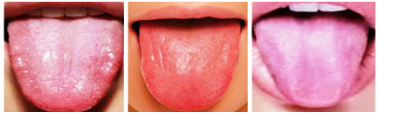

Fig. 7: Healthy Tongue Images

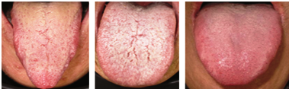

Fig. 8: Tongue Images (from left to right) with (a) Vatadosha, (b) Pitta doshaand (c) Kaphadosha

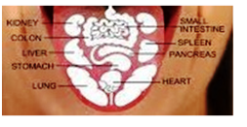

Fig. 9: Tongue Interpretation

A healthful tongue needs to look like a children's tongue: symmetric and frivolously crimson, need to be supple, freed from cracks and no longer quiver or tremble. It should be barely moist. Whilst the tongue is sticking out, it's clearly straight rather than curving to one side. It ought to stay still, without shaking, soft, and stiff. It have to have a skinny , obvious coating, colouring the tongue pink. All the taste buds are flat, orderly and unfastened from strawberry-looking bumps, deep cuts, lines, cracks and patches. It must no longer have foam, hair, fur, be too dry or too wet or have a foul odour or flavor; a healthful tongue should have a few coating.

A discolouration and sensitivity of the tongue area suggests a ailment in the organ or a part of the body associated with the same.Various colour indications are visible from white,greenish to yellow tongue. A white colour tongue shows kapha derangement and mucus accumulation; a crimson or yellowish-green tongue shows pitta derangement; and a blackish-2brown colouration suggests vata derangement. A dry or sticky tongue is symptomatic of a decrease in the dhatu rasa (plasma), while a light tongue suggests a decrease within the dhatuRakta (red blood cells).

The part of the tongue is divided into blocks. The part from the tip of the tongue till 1/3rd part pertains to the neck, chest, heart and the lunges. The essentials of the health of the above mentioned parts of the body would be in reference to the tip part of the tongue. A froth in this region I an indication of dampness, cold, ashtma, bronchitis or a respiratory problem. The emotion if sadness and depression is related to the area of despair in heart region. The abdominal organs and the intestine, colon region can be studied with the rear one-third of the tongue.

1. Methodology

The region of the tongue image plays a vital role in further classification which makes the segmentation a crucial process. The data acquired are segmented using simple thresholding segmentation method with the average of obtained mean pixel value and maximum repeated intensity value. Tongue image segmentation is a vital part of the automated diagnosis methodologies. There are various approaches of tongue segmentation, few methods are discussed here. Shi, Li, Li, and Xu (2012), used geodesic active contour model to segment the tongue region. Shi, Li, and Li (2013) and Liang and Shi(2012) have utilized the tongue features related to shape and location. Many researchers ( Li , 2009; Zhai, Lu, and Zhang ,2009; Wang, Zhang, and Li,2011; Fu, Li, and Li, 2001; Xu and Prince,1998; Xu and Prince,1997) used the variants of snake model to segment the region of interest. Ning, Zhang, Wu, and Yue (2012) proposed to segment the tongue image into parts using watershed algorithm.

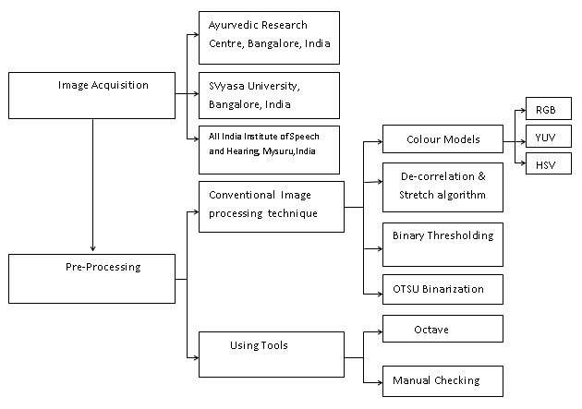

Fig. 10 (a): Proposed tongue acquisition and pre-processing

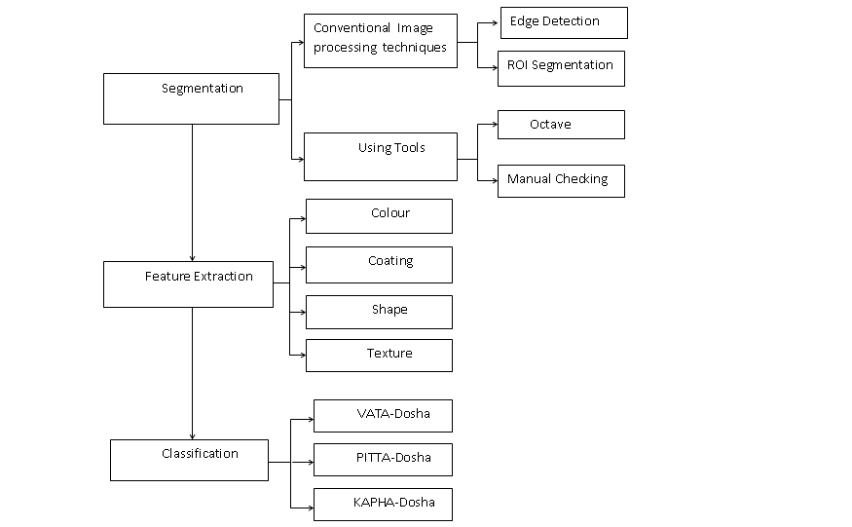

Fig. 10(b): Proposed tongue segmentation and classification

They are further segmented with ROI (region of interest) segmentation to obtain the exact portion of the tongue. Features are extracted on the segmented image for further classifying into Vata, Pitta, Kapha. A single characteristic might not be very discriminative, so we ought to collect many capabilities from tongue photographs based on colour, texture, coating and shapes. These features are given to the model to determine the health status.

3.1 Image Acquisition and colour model mappings

The data collection step was accounted with capturing of tongue images of 270 healthy and unhealthy patients. Individual image health record has been taken into account on which the model would be trained and tested. All features of tongue colour, coating, texture, shape is taken as the input to the model. Zhai, Lu, and Zhang (2009) used colour mapping and filters to perform the pre-processing. De-correlation and stretch algorithm, threshold (binary thresholding, ROI extraction), Otsu’s binarization methods are carried out to extract the region of interest. Classification to be carried out after the segmentation of ROI from tongue image based on required features. The model prediction of Vata Pitta, Kapha is the last step with the test data confirming the grouping of images. In a machine-vision based tongue diagnosis system, background needs to be separate out from tongue image. Below are the normalised intensities of red, green and blue respectively.

$r_{i}=R_{i}$**/255**

$g_{i}=G_{i}$**/255**

$b_{i}$**= $B_{i}$/255**

YIQ model refers to the Luminance of intensity and I/Q channels represents colour information.

$\begin{matrix}Y_{i} \\ I_{i} \\ Q_{i}\end{matrix}$**= $\begin{matrix}0.299 & 0.589 & 0.114 \\ 0.596 & -0.274 & -0.322 \\ 0.211 & -0.523 & 0.312\end{matrix}\begin{matrix}r_{i} \\ g_{i} \\ h_{i}\end{matrix}$**

Heu Saturation and Value(HSV) is the cylindrical system where we separate 3 of the most primary properties of colours and represent those using different channels.

$$V=max⁡(r, g, b)$$

$$S=\left\{\begin{aligned}0 if S=0 \\ 60*\frac{\min\left(r,g,b\right)}{v} if V>0 \end{aligned}\right.$$

$$H=\left\{\begin{aligned}0 if S=0 \\ 60*\frac{g-b}{S*V}if V=r\end{aligned}\right.$$

$$H=\left\{\begin{aligned}60*[2+\frac{b-r}{S*V} ]f V=g \\ 60*\left[4+\frac{r-g}{S*V}\right]if V=b\end{aligned}\right.$$

3.2 Primary Segmentation

3.2.1 De-Correlation and stretch algorithm

This is the first method of primary segmentation. Decorrelation is a layman's term for a process that is used to reduce autocorrelation within a image, or cross-correlation within a set of images, while preserving other aspects of the image. Researchers (C. Xu and J. Prince, 2000; C. Xu, D. Pham, and J. Prince, 2000; C. Xu and J. Prince, 2009; N. Paragios, O. Mellina-Gottardo, and V. Ramesh,2004; N. Paragios, O. Mellina-Gottardo, and V. Ramesh, 1998) also used the Gradient vector flow model for basic segmentation of images.

Algorithm:

Input: the obtained tongue image Ti.

Output: three-channel image Si.

1. Pixel values are reprented as data points and are drawn into a (m * n) matrix. Then this three column vectors are arranged in columns to form a (m * n) * 3 matrix A.

2. Covariance Cv matrix and the decomposition will produce a matrix with Eigen vales(D) and Eigen vectors(V), so that Cv * V = V * D.

3. Find out the transform matrix T using formula T = $t=t ×uD^{-1/2}$ V * D-1/2 * VT

4. De-correlate matrix A by right multiplication A = A * T

5. Reshape A back to obtain a three-channel image matrix S .

6. Enhance contrast for each band of S by adjusting histogram.

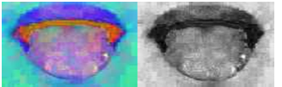

Fig. **11**: Obtained results for De-Correlation and stretch algorithm

3.2.2 Binary Thresholding

From the image obtained using De-Correlation binary thresholding is carried out for the image. It is the simplest thresholding process which separates the region of image corresponding to the object which we want to analyse. The differentiating parameter is the threshold value. A comparison of each pixel value with respect to the threshold value is done classifying into 0(black) or 255 (white) values. Usually background pixels have low values and easily can be removed by applying the heuristic threshold values, θ thrwhich is calculated by the following.

$θ_{thr}$ = ${(θ}_{MaxRep }$ + $θ_{Median}$)/2

This Binary thresholdingoperation can be expressed as:

$$dist\left(x,y\right)= \left\{\begin{aligned}maxVal if src\left(x,y\right)>thresh \\ 0 otherwise\end{aligned}\right.$$

Thresholding Binary inverted operation:

$$dist\left(x,y\right)=\left\{\begin{aligned}0 if scr\left(x,y\right)>thresh \\ maxVal otherwise\end{aligned}\right.$$

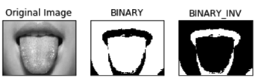

Fig. 12: Binary thresholding

3.2.3 Otsu Binarization

The final step of primary segmentation is Otsu binarization. Otsu binarization,named after Nobuyuki Otsu performs image thresholding.The algorithm uses a single intensity value. It classifies the images into foreground or background based on threshold value,where the sum these values spans a minimal. A white class variance is determined using the weights associated.. Let t to be the threshold value. The threshold subdivides the tongue picture into two classes: c0 and c1. Now calculate the class variance of the segmented classes c0 and c1.

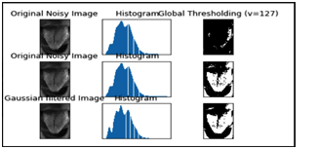

Fig. 13:Otsu binarization with histogram values

* 1. SECONDARY SEGMENTATION

ROI segmentation is the primarily technique in secondary segmentation manner. This '**Area of Interest'** or **ROI** generally is decided on the premise of pixel intensity values or person-decided regions (through drawing and subsequent protecting). **Segmentation** is referred to as manner of isolating objects of interest from uninteresting objects**.**

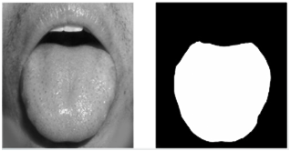

Fig. 14: ROI Segmentation

A segmented picture based totally on thresholded intensity is separated into uninteresting from interesting pixels. Once segmented, the picture pixels may be reassigned the intensity values of either zero or 1. On this operation geometry remains the identical, but the grayscale image is converted right into a binary image along with simplest depth 1 or zero. Figuring out morphometrics is a system of counting adjoining pixels with a cost of one and ignoring those with a value of zero. If depth values are required, then the binary photo may be used as a**masks** to overlay the unique image exposing most effective the roi pixels. As soon as masked, the depth values of the photograph may be obtained.

1. Future Work and Conclusion
   1. EDGE DETECTION

A method that extract beneficial structural records from one-of-a-kind imaginative and prescient objects and dramatically lessen the amount of information to be processed is known **as canny edge detection**. It is been substantially carried out in computer vision systems. Canny has discovered that the requirements for the utility of edge detection on diverse vision structures are exceedingly similar. As a consequence, an edge detection approach to deal with those necessities may be achieved in a extensive kind of situations.

* 1. FEATURE EXTRACTION

The final step of the process is classification of the model into vata, pitta, kapha. Before the process we have to extract the required features based on colour, coating, texture and shape. These feature extraction help in the better classification of the model.

Colour models refers to a selected manner of organizing colours. A colour model is actually a combination of two things: a colour model and a mapping feature. The motive we want colour models is because it allows us in representing pixel values using tuples. The mapping function maps the colour model to the set of all possible colours that can be represented. There are many different colour models that are useful. RGB, YUV, HSV, Lab are some of the most popular colour models. Different colour models provide exclusive advantages. We simply need to choose the colour model that is right for the given problem.. A set of 25 features, that span the entire colour models. They can be grouped under eight categories:RGB, HSV, YIQ, YCbCr, XYZ, Lab, CIE Luv, and CMYK.

* 1. CLASSIFICATION
     1. SUPPORT VECTOR MACHINE ALGORITHM(SVM)

A supervised machine learning algorithm which can be used to adopt for both classification or regression challenges is referred to as **support vector machine**. However, it is mostly used in classification problems. We have used this algorithm to plot the tongue images in an N dimensional space where the value refers to a coordinate assigned. A hyper plane representation of the values are obtained based on Boolean values obtained.

. As a quick refresher, the dot product of two vectors is proportional to the projection of the first vector on to the second. If it’s a positive sample, we’re going to insist that the proceeding decision function (the dot product of w and the position vector of a given sample plus some constant) returns a value greater than or equal to 1.

* + 1. KNN CLUSTERING ALGORITHM

The supervised machine learning algorithm knn is used for classification and regression. Proximity of information points is taken under consideration and the dataset is classified based on k values.

Algorithm:

1. Load the input data.

2. k value should represent the number of clusters to be formed in the data.

3.The gap between each enter factor and the cluster centroid is calculated to assign it to an current cluster

4. Return the mean of the klabels,for regression

5. Return the mode of the klabels,for classification

Using the above KNN and SVM classification models we propose to predict the input images into the groups of vata, pitta, kapha.

1. CONCLUSION

In this proposed work we acquired the images and we segmented tongue and non-tongue regions of the images. The colour mapping has been done considering RGB, HSV and YIQ colour models. Primary image segmentation has been carried out using De-Correlation and stretch algorithm, Binary thresholding and Otsu binarization. Later on ROI segmentation and edge detection is carried out. The classification into vata, pitta and kapha is carried out using SVM, KNN classification.

REFERENCES

M. J. Shi, G. Z. Li, F. F. Li, and C. Xu, “A novel tongue segmentation approach utilizing double geodesic flow,” in Proceedings of the 7th International Conference on Computer Science and Education (ICCSE ’12), pp. 21–25, Melbourne, Australia, July 2012.

M. J. Shi, G. Z. Li, and F. F. Li, “C2 G2 FSnake: automatic tongue image segmentation utilizing prior knowledge,” Science China Information Sciences, vol. 56, no. 9, pp. 1–14, 2013.

C. Liang and D. C. Shi, “A prior knowledge-based algorithm for tongue body segmentation,” in Proceedings of the International Conference on Computer Science and Electronics Engineering (ICCSEE ’12), pp. 646–649, Hangzhou, China, March 2012.

X. M. Zhai, H. D. Lu, and L. Z. Zhang, “Application of image segmentation technique in tongue diagnosis,” in Proceedings of the International Forum on Information Technology and Applications (IFITA ’09), pp. 768–771, Chengdu, China, May 2009.

SJ. F. Ning, D. Zhang, C. K. Wu, and F. Yue, “Automatic tongue image segmentation based on gradient vector flow and region merging,” Neural Computing and Applications, vol. 21, no. 8, pp. 1819–1826, 2012.

SS. X. Li, “Automatic segmentation of tongue image based on histogram threshold and snakes model,” Journal of University of Science and Technology Liaoning, vol. 32, no. 6, pp. 585–590, 2009.

M. Y. Wang, X. F. Zhang, and Z. Li, “An improved snakes model for tongue image segmentation,” Measurement and Control Technology, vol. 30, no. 5, pp. 32–35, 2011.

Z. C. Fu, X. Q. Li, and F. F. Li, “Tongue image segmentation based on snake model and radial edge detection,” Journal of Image and Graphics, vol. 14, no. 4, pp. 688–693, 2009.

N. Paragios, O. Mellina-Gottardo, and V. Ramesh, “Gradient vector flow fast geometric active contours,” IEEE Transactions on Pattern Analysis and Machine Intelligence, no. 3, pp. 402–407, 2004.

N. Paragios, O. Mellina-Gottardo, and V. Ramesh, “Gradient vector flow fast geodesic active contours,” in Proc. of IEEE International Conference on Computer Vision, 2001.

C. Xu and J. Prince, Handbook of Medical Imaging: Processing and Analysis Management, ch. Gradient Vector Flow Deformable Models. Academic Press, 2000.

C. Xu, D. Pham, and J. Prince, Handbook of Medical Imaging: Processing and Analysis Management, ch. Image Segmentation Using Deformable Models, pp. 129–174. Academic Press, 2000.

C. Xu and J. Prince, “Generalized gradient vector flow external forces for active contours,” Signal Processing, no. 3, pp. 131–139, 1998.

C. Xu and J. Prince, “Snakes, shapes, and gradient vector flow,” IEEE Transactions on Image Processing, no. 3, pp. 359–369, 1998.

C. Xu and J. Prince, “Gradient vector flow: a new external force for snakes,” in Proc. of IEEE Conference on Computer Vision and Pattern Recognition, pp. 66–71, 1997.

S.Dey, P Pahwa, “Prakriti and its associations with metabolism, chronic diseases, and genotypes: Possibilities of new born screening and a lifetime of personalized prevention”, Journal of Ayurveda & Integrative Medicine, vol. 5, no. 1, pp. 15-24, 2014.

V. J. Thakar, “Diagnostic methods in ayurveda”, Ancient Science of Life, vol.1, no.3 , pp. 139 – 145, 1982.

INDEX

Ayurveda, 1, 2, 3, 4, 11

Binary Thresholding, 8

blackish-2brown, 5

**canny edge detection**, 10

De-Correlation and stretch algorithm, 7, 8, 11

EDGE DETECTION, 10

HSV, 7, 10, 11

Introduction, 1

KNN CLUSTERING, 10

Methodology, 5

Nadi, 3

Ostha, 3

Otsu Binarization, 9

**prakruti**., 2

ROI, 7, 9, 11

SVM, 10

thresholded intensity, 9

vata, pitta, kapha, 1, 10

white colour, 5

yellowish-green, 5

YIQ, 7, 10, 11